**Spring Rest 2**

**Exercise 1: Hello World RESTful Web Service**

**Code:**

@RestController  
public class HelloController {  
  
 @GetMapping("/hello")  
 public String sayHello(){  
 return "Hello World!";  
 }  
}

@SpringBootApplication  
public class SpringLearnApplication {  
 private static final Logger *LOGGER* = LoggerFactory.*getLogger*(SpringLearnApplication.class);  
 public static void main(String[] args) {  
 SpringApplication.*run*(SpringLearnApplication.class, args);  
 }  
}

**Output:**

**1.Chrome**

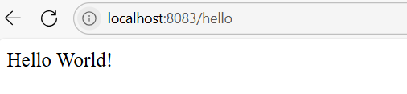

**2.Postman**

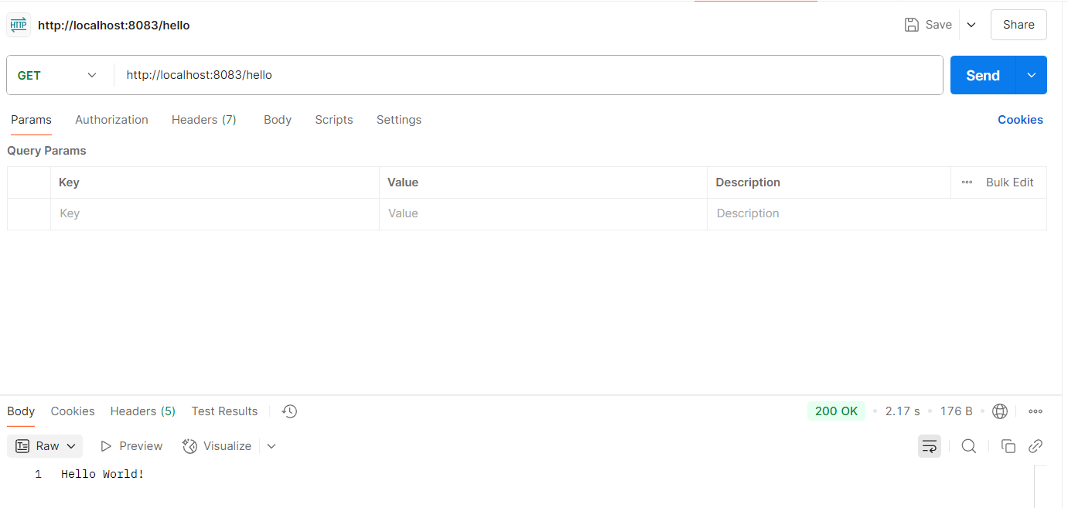

**Exercise 2: REST - Country Web Service**

**Code:**

public class Country {  
 private String code;  
 private String name;  
  
 public Country() {  
 System.*out*.println("Inside Country Constructor.");  
 }  
  
 public String getCode() {  
 System.*out*.println("Inside getCode()");  
 return code;  
 }  
  
 public void setCode(String code) {  
 System.*out*.println("Inside setCode()");  
 this.code = code;  
 }  
  
 public String getName() {  
 System.*out*.println("Inside getName()");  
 return name;  
 }  
  
 public void setName(String name) {  
 System.*out*.println("Inside setName()");  
 this.name = name;  
 }  
  
 @Override  
 public String toString() {  
 return "Country [code=" + code + ", name=" + name + "]";  
 }  
}

@RestController  
public class CountryController {  
  
 private static final Logger *LOGGER* = LoggerFactory.*getLogger*(CountryController.class);  
  
 @RequestMapping("/country")  
 public Country getCountryIndia(){  
 ApplicationContext context = new ClassPathXmlApplicationContext("country.xml");  
 Country country = context.getBean("country", Country.class);  
 return country;  
 }  
}

<bean id="country" class="com.cognizant.spring_learn.controller.Country">  
 <property name="code" value="IN"/>  
 <property name="name" value="India"/>  
</bean>

**Output:**

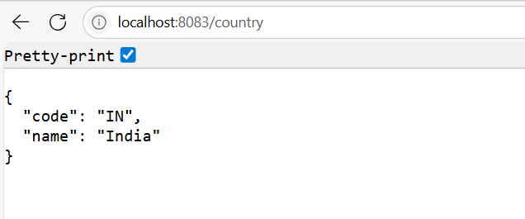

**Exercise 3: Get country based on country code**

**Code:**

public class Country {  
 private String code;  
 private String name;  
  
 public Country() {  
 System.*out*.println("Inside Country Constructor.");  
 }  
  
 public String getCode() {  
 System.*out*.println("Inside getCode()");  
 return code;  
 }  
  
 public void setCode(String code) {  
 System.*out*.println("Inside setCode()");  
 this.code = code;  
 }  
  
 public String getName() {  
 System.*out*.println("Inside getName()");  
 return name;  
 }  
  
 public void setName(String name) {  
 System.*out*.println("Inside setName()");  
 this.name = name;  
 }  
  
 @Override  
 public String toString() {  
 return "Country [code=" + code + ", name=" + name + "]";  
 }  
}

@Service  
public class CountryService {  
  
 public Country getCountry(String code) {  
 ApplicationContext context = new ClassPathXmlApplicationContext("country.xml");  
 List<Country> countries = (List<Country>) context.getBean("countryList");  
 return countries.get(0);  
 }  
}

<bean id="country" class="com.cognizant.spring_learn.controller.Country">  
 <property name="code" value="IN"/>  
 <property name="name" value="India"/>  
</bean>  
<bean id="countryList" class="java.util.ArrayList">  
 <constructor-arg>  
 <list>  
 <ref bean="country" />  
 </list>  
 </constructor-arg>  
</bean>

@SpringBootApplication  
public class SpringLearnApplication {  
 public static void main(String[] args) {  
 SpringApplication.*run*(SpringLearnApplication.class,args);  
 }  
}

**Output:**

